**SQL for Data Science**

**SQL Fundamentals - 1**

**Relational Databases :**

**A relational database is one that stores data in tables. The relationship between each data point is clear and searching through those relationships is relatively easy. The relationship between tables and field types is called a schema. For relational databases, the schema must be clearly defined.**

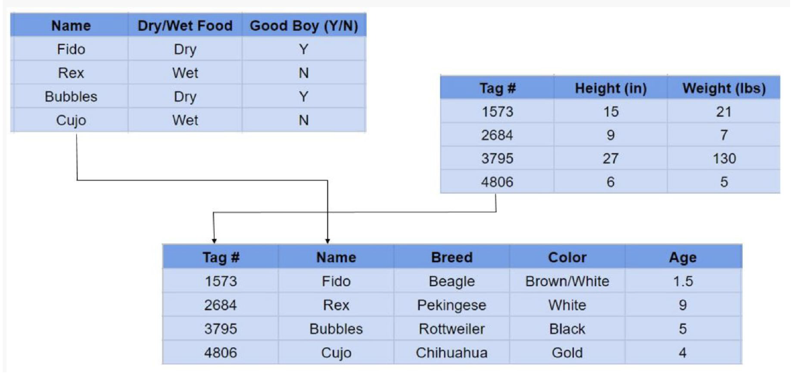

**Non-Relational Databases :**

**A non-relational database is any database that does not use the tabular schema of rows and columns like in relational databases. Rather, its storage model is optimized for the type of data it’s storing.**

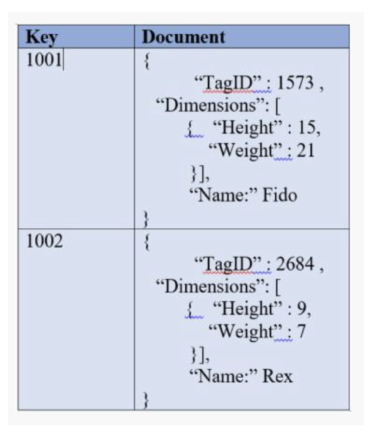

**There are four different types of NoSQL databases.**

**Document-oriented databases – Also known as a document store, this database is designed for storing, retrieving and managing**

**document-oriented information. Document databases usually pair each key with a complex data structure (called a document).**

**Key-Value Stores – This is a database that uses different keys where each key is associated with only one value in a collection. Think of it as a dictionary. This is one of the simplest database types among NoSQL databases.**

**Wide-Column Stores – This database uses tables, rows, and columns, but unlike a relational database, the names and format of the columns can vary from row to row in the same table.**

**Graph Stores – A graph database uses graph structures for semantic queries with nodes, edges, and properties to represent and store data.**

**How to choose a**

1. **What type of data will you be analyzing ?**
2. **How much data are you dealing with?**
3. **What kind of resources can you devote to the setup and maintenance of your database?**
4. **Do you need real-time data?**

**Introduction to SQL:**

**SQL (Structured Query Language) is a computer language aimed to store, manipulate and retrieve data stored in relational databases.**

**SQL language has several parts:**

**1) DDL - Data Definition Language**

**2) DML - Data Manipulation Language**

**3) View Definition**

**4) Transaction Control**

**Data Definition Language: DDL statements are used to define the database structure or schema.**

**Examples :**

**1) CREATE**

**2) ALTER**

**3) DROP**

**4) RENAME**

**Data Manipulation Language: DML statements are used for managing data within schema objects. Examples :**

**1) SELECT**

**2) INSERT**

**3) UPDATE**

**4) DELETE**

**Basic Structure of SQL Query:**

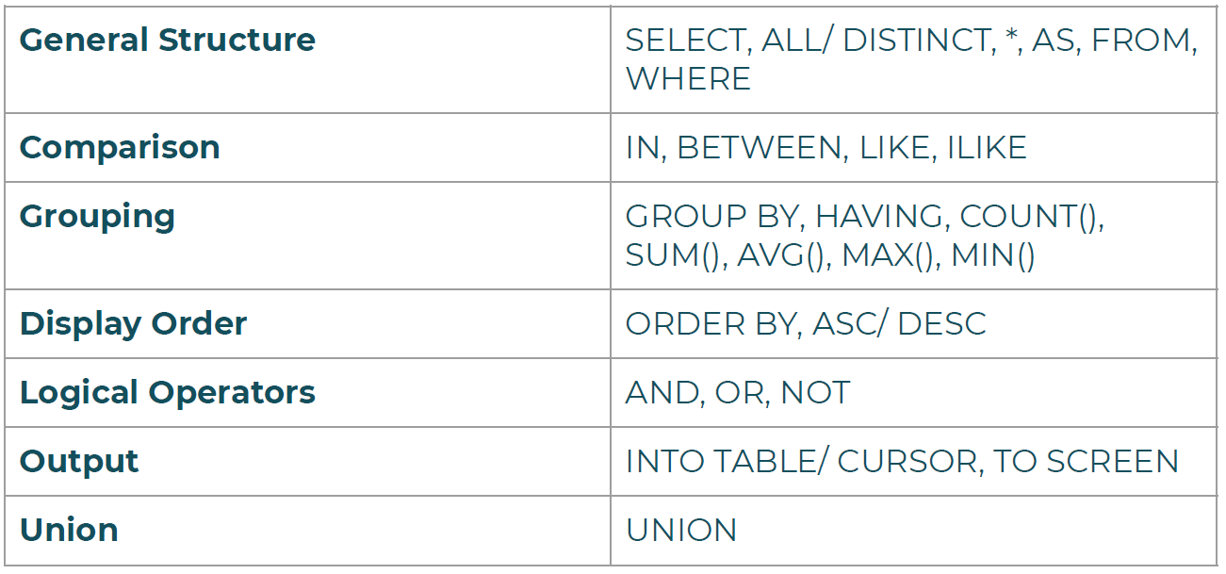

**SELECT & DISTINCT Statement:**

**SELECT** is the most common statement used, and it allows us to

retrieve information from a table.

In order to select the entire table **SELECT \*** is used.

Sometimes a table contains a column that has duplicate values

and in order to return only the unique values, **DISTINCT** statement

is used in combination with **SELECT**

**COUNT Statement:**

COUNT returns the number of input rows that match a specific

condition of a query.

COUNT can be applied on a specific column or just passed as

COUNT(*), both giving same results

**WHERE statement:**

WHERE statement allows us to specify the conditions on columns for the rows to be returned.

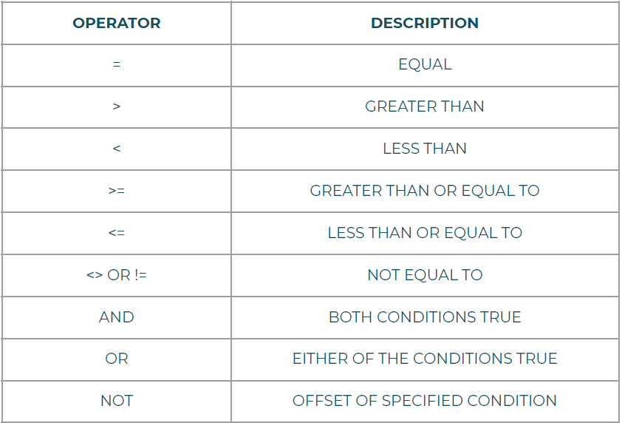

**ORDER BY Statement:**

SELECT company, name, sales FROM table

ORDER BY company, sales

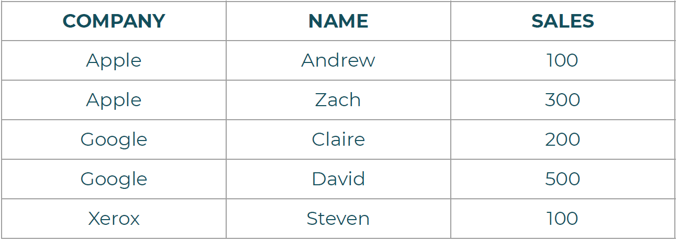

**LIMIT Statement:**

The LIMIT command allows us to limit the number of rows returned for a query.

Useful for not wanting to return every single row in a table, but only view the top few rows to get an idea of the table layout

LIMIT also becomes useful in combination with ORDER BY

LIMIT goes at the very end of a query request and is the last command to be executed.

**BETWEEN Statement:**

The BETWEEN operator can be used to match a value against a

range of values

value **BETWEEN** low **AND** high

Can be combined with **NOT** operator

Can be also used with dates in the format : YYYY-MM-DD

**IN Statement:**

The IN operator can be used to create a condition that checks to

see if a value is included in a list of multiple options for example if a user’s name shows up in a list of know names

value **IN** ( option 1, option 2, option 3,........., option N )

**LIKE & ILIKE Statement:**

In order to match a string against a general pattern we use LIKE

and **ILIKE** for example:

All emails ending with ‘@gmail.com’

**LIKE & ILIKE** allows us to perform pattern matching against string

data with the use of wildcard characters

● **Percent %** - Matches any sequence of characters

● **Underscore _** - Matches any single character

**LIKE** is case-sensitive whereas ILIKE is case-insensitive

**LIKE & ILIKE Statement:**

All names that begin with ‘A’

**WHERE** name **LIKE** ‘A%’

All names that end with ‘a’

**WHERE** name **LIKE** ‘%a’

Get all Mission Impossible Films

**WHERE** name **LIKE** ‘Mission Impossible _ _’

Combination of Wildcards

**WHERE** name LIKE ‘_ her%’

● Cheryl

● Theresa

● Sherri

**Aggregate Functions:**

The main idea behind aggregate function is to take multiple inputs and return a single output.

● **AVG()** - Returns floating point values.

●**ROUND()** can be used to specify precision after the decimal

● **COUNT()**

● **MAX()**

**● MIN()**

**● SUM()**

**GROUP BY Statement:**

**GROUP BY** allows us to aggregate data and apply functions to

better understand how data is distributed per category.

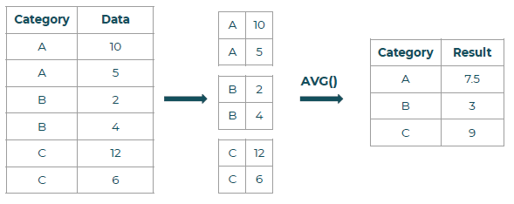

**HAVING BY Statement:**

**HAVING** allows us to filter after an aggregation has already taken

place.

We can use it along with a **GROUP BY**

**AS Statement**

**AS** allows us to create an Alias for a column or a result.

**AS** operator gets executed at the very end of the query meaning we can not use the Alias inside a **WHERE** or **HAVING** operator.

**INNER JOIN Statement:**

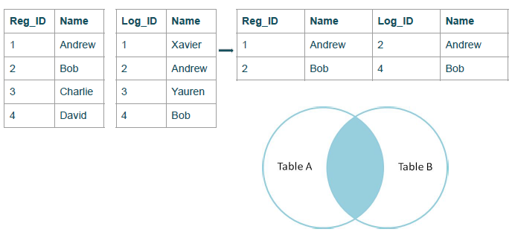

**FULL OUTER JOIN Statement:**

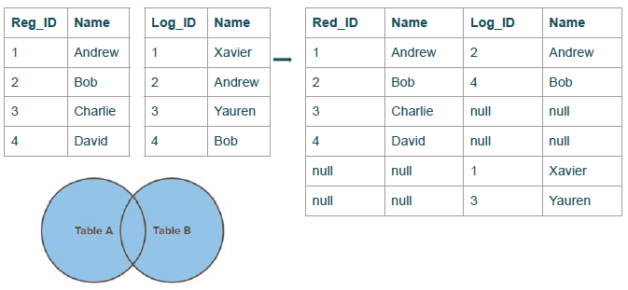

**FULL OUTER JOIN with WHERE:**

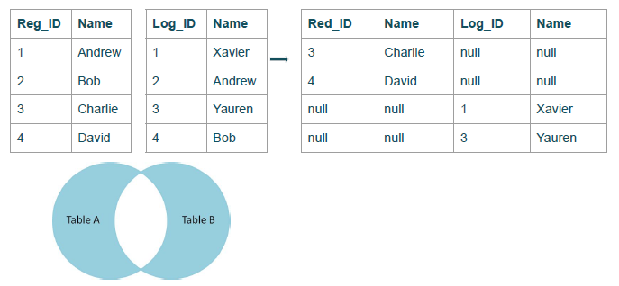

**LEFT OUTER JOIN Statement:**

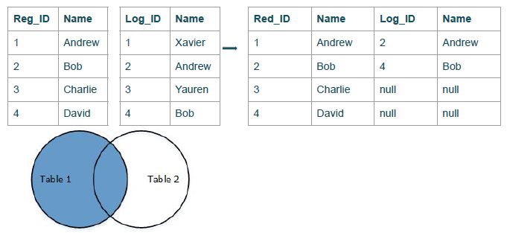

**LEFT OUTER JOIN with WHERE:**

